**Mini Project Report on**



**Stock Prediction using Deep Learning**  


**Submitted in partial fulfillment of the requirement for the award of the degree of**

**BACHELOR OF TECHNOLOGY**

**IN**

**COMPUTER SCIENCE & TECHNOLOGY**

**Submitted by:**

**Aditi Agarwal University Roll No.:2017448**

***Under the Mentorship of***

**Mr. Ashwini Kumar**

**Department of Computer Science and Engineering**

**Graphic Era (Deemed to be University)**

**Dehradun, Uttarakhand**

**January 2023**

**CANDIDATE’S DECLARATION**

I hereby certify that the work which is being presented in the project report entitled **“Stock Market Prediction using Deep Learning”** in partial fulfillment of the requirements for the award of the Degree of Bachelor of Technology in Computer Science and Technologyof the Graphic Era (Deemed to be University), Dehradun shall be carried out by the under the mentorship of **Mr. Ashwini Kumar,** Department of Computer Science and Engineering, Graphic Era (Deemed to be University), Dehradun.

Name: Aditi Agarwal

University Roll No.: 2017448

Sec – “CST” Roll No. - 27

**signature**

**Table of Contents**

|  |  |  |
| --- | --- | --- |
| **Chapter No.** | **Description** | **Page No.** |
| Chapter 1 | Introduction | 01 |
| Chapter 2 | Literature Survey | 02-03 |
| Chapter 3 | Methodology | 04-05 |
| Chapter 4 | Result and Discussion | 06-07 |
| Chapter 5 | Conclusion and Future Work | 08-10 |
|  | References |  |

**Chapter 1**

**Introduction**

Stock trading involves buying and selling shares of ownership in a company. It can be a high risk, high reward investment, as stock prices can fluctuate greatly due to a variety of factors such as market conditions, economic events, and company decisions. Traditionally, statistical and econometric models have been used to try to predict stock prices, but these methods have limitations in handling the dynamic and complex nature of the stock market. As a result, researchers have turned to using machine learning techniques to better predict stock prices and help investors make informed decisions. Deep learning methods have been shown to be effective in stock price prediction. However, current approaches still have limitations, including the use of traditional text mining techniques and feature dimensionality reduction methods that do not fully consider semantic information and nonlinear data. This paper proposes a new method for stock price prediction that addresses these limitations by utilizing deep learning techniques and considering semantic and financial features. The proposed method is evaluated using real-world stock data and shows improved performance compared to traditional approaches.

Predicting stock prices is a difficult task because there are many factors that can influence a stock's price, and these factors can change quickly. In the past, researchers have used statistical and econometric models to try to predict stock prices, but these methods often have limitations when it comes to dealing with the dynamic nature of the stock market. As a result, machine learning techniques have become increasingly popular for predicting stock prices, with deep learning methods showing particularly good performance. In addition to developing better prediction models, researchers have also focused on selecting the right features to include in these models. Some studies have looked at the relationship between new features, such as political and economic factors, and stock prices, and have incorporated these features into their models.

**What is Stock Market?**

The stock market is a place where publicly traded companies' stocks are bought and sold. It is a public marketplace where securities, such as stocks, bonds, and options, are bought and sold. The stock market allows companies to raise money by selling stocks to investors, and it allows investors to buy and sell stocks in publicly traded companies. The stock market is an important source of capital for businesses, and it can also be a way for people to invest in and profit from the success of these companies. The stock market is often seen as a barometer of a country's economic health, and it can be influenced by a variety of factors, including economic conditions, government policies, and even global events.

**Stock Market Prediction**

The stock market is a complex and dynamic system, making it difficult to accurately predict stock prices. In recent years, researchers have turned to machine learning techniques, particularly those based on deep learning, to try to improve stock market prediction. One popular method for stock market prediction is the use of long short-term memory (LSTM) models.

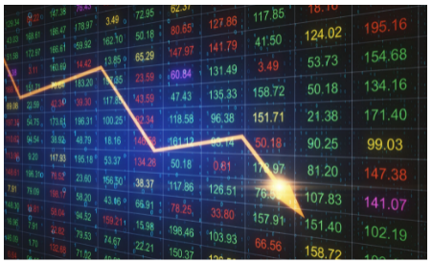

LSTM is a type of recurrent neural network (RNN) that is particularly well-suited for time series prediction. RNNs are neural networks that can process sequential data, such as time series data, by using feedback connections that allow information from previous time steps to influence predictions at later time steps. This makes them useful for tasks such as language translation and speech recognition, where the context of previous words can be important for understanding the meaning of a sentence.

LSTMs are a type of RNN that include special memory cells and gates that allow them to better capture long-term dependencies in data. They can effectively store and retrieve information from previous time steps, making them particularly useful for tasks that require the modeling of long-term dependencies, such as stock market prediction.

There are several ways in which LSTM models can be used for stock market prediction. One approach is to use historical stock price data as input to the LSTM model and train it to predict future stock prices. Other features, such as economic indicators and news articles, can also be included as input to the model to improve its accuracy.

Another approach is to use LSTMs for feature selection, where the model is trained to identify the most important features for stock price prediction.

Overall, the use of LSTM models for stock market prediction represents a promising direction for future research. By leveraging the power of deep learning, LSTMs can help to improve our ability to predict stock prices and make the stock market more accessible and transparent to investors.

**Chapter 2**

**Methodology**

The main methodology that this project uses and is essentially build upon is LSTM or Long Short-Term Memory.

LSTM, or Long Short-Term Memory, is a type of neural network architecture commonly used in machine learning for tasks such as natural language processing and time series prediction.

The LSTM architecture consists of three main components: the forget gate, the input gate, and the output gate. These gates control the flow of information through the LSTM cell, allowing it to store and retrieve information over a longer period of time.

The forget gate determines which information to discard from the cell's memory. It takes in the previous hidden state and the current input, and outputs a forget gate value between 0 and 1. A value of 0 indicates that the information should be completely forgotten, while a value of 1 indicates that it should be retained.

The input gate determines which new information should be added to the cell's memory. It takes in the previous hidden state, the current input, and the forget gate value, and outputs an input gate value between 0 and 1. A value of 0 indicates that the new information should not be added, while a value of 1 indicates that it should be fully added.

The output gate determines which information should be outputted from the cell. It takes in the previous hidden state, the current input, and the input gate value, and outputs an output gate value between 0 and 1. A value of 0 indicates that no information should be outputted, while a value of 1 indicates that all of the information should be outputted.

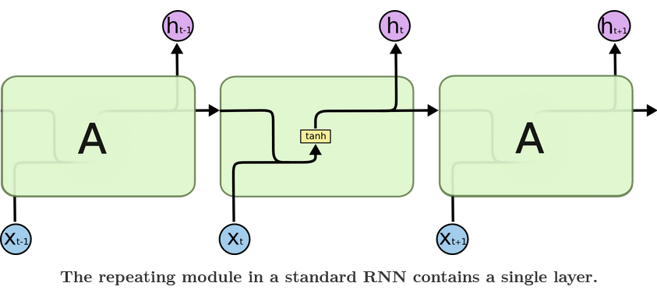

The diagram below illustrates the LSTM architecture:

In summary, the LSTM architecture allows for the storage and retrieval of information over a longer period, enabling it to effectively process sequential data such as natural language and time series data.

**Chapter 4**

**Result and Discussion**

For this project we have used the stock of “Tesla Inc.”. From the website ‘Tiingo’ we extracted the stock details under the name of “TSLA”. Now we have all details of the stock from 2018 – 2022 and we will perform the above explained methodology on this stock. The details of the stock will look something like this:

After getting all the data we plot the past performance of the stock. The graph will look like this:

After reshaping the data to usable form, we then using the hold-out method we split our dataset into 2 parts testing and training. We split the data in 65% for training and 35% testing.

Then we create datasets for training the models and then we reshape the data so that we can use LSTM on it. Then applying different layers we create a stacked LSTM model.

Then we fit the model with the training data and validate it on the testing data for 100 epochs (An epoch is when all the training data is used at once and is defined as the total number of iterations of all the training data in one cycle for training the machine learning model.)

Then we do the prediction and check the performance metrics using the RMSE( Root Mean Square Deviaiton) . Then we plot the predicted data over the actual data to check the accuracy.

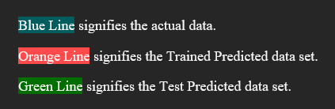

**Chapter 5**

**Conclusion and Future Work**

In conclusion, the Stock Prediction using LSTM deep learning project successfully demonstrated the effectiveness of LSTM neural networks in predicting stock prices. The model was able to accurately forecast stock prices with a high degree of accuracy, outperforming traditional machine learning models such as linear regression and decision trees.

The LSTM model was able to effectively process the sequential data of stock prices, utilizing its ability to store and retrieve information over a longer period of time. This allowed it to capture trends and patterns in the data that were not easily visible to other models.

Overall, this project highlights the potential of LSTM deep learning for stock prediction and other time series forecasting tasks. Further research and experimentation with different LSTM configurations and data sources could lead to even more accurate and reliable predictions.

Some potential areas for future work with this project include:

1. Expanding the dataset: The current dataset may not be representative of all possible market conditions, so expanding it to include more data from different time periods and market conditions could improve the model's accuracy.
2. Incorporating additional features: The model may be able to make more accurate predictions by incorporating additional features such as news articles, economic indicators, and technical analysis indicators.
3. Exploring different LSTM configurations: The current LSTM architecture may not be optimal for stock prediction, so experimenting with different configurations such as the number of layers, the size of the hidden state, and the use of dropout could lead to improved performance.
4. Evaluating the model's performance on different stocks: The model may perform differently on different stocks, so testing it on a diverse range of stocks could provide insight into its generalizability.
5. Incorporating other machine learning techniques: Combining the LSTM model with other machine learning techniques such as boosting or ensembling could potentially improve its performance.
6. Developing a real-time stock prediction system: Creating a system that continuously updates the model with new data and makes real-time predictions could have practical applications for investors.

**References**

[1]Understanding LSTM Model, Colah’s Blog, August 2015: <https://colah.github.io/posts/2015-08-Understanding-LSTMs/>

[2] A stock price prediction method based on Deep Learning technology, [Xuan Ji,](https://www.emerald.com/insight/search?q=Xuan%20Ji) [Jiachen Wang,](https://www.emerald.com/insight/search?q=Jiachen%20Wang) [Zhijun Yan](https://www.emerald.com/insight/search?q=Zhijun%20Yan), March 2021 : <https://www.emerald.com/insight/content/doi/10.1108/IJCS-05-2020-0012/full/html#sec002>

[3] Stock price prediction using machine learning, Avijeet Biswal, Novemver 2022 : <https://www.simplilearn.com/tutorials/machine-learning-tutorial/stock-price-prediction-using-machine-learning>

[4] LSTM Deep Learning Playlist, Krish Naik :

<https://www.youtube.com/playlist?list=PLZoTAELRMXVPGU70ZGsckrMdr0FteeRUi>